# Steps for setting up Visual Studio and including MVS:

Step (1): Installing The Visual Studio Community 2022.

Link:

[Https://Visualstudio.Microsoft.Com/Thank-You-Downloading-Visual-Studio/?Sku=Community&Channel=Release&Version=Vs2022&Source=Vslandingpage&Cid=2030&Passive=False](https://visualstudio.microsoft.com/thank-you-downloading-visual-studio/?sku=Community&channel=Release&version=VS2022&source=VSLandingPage&cid=2030&passive=false)

Necessary: Development Kit For C

(1) Available When The Installer Is Launched.

(2) If Only The Bare Minimum Version Is Installed Which Is Approx Around 1.5 Gb – 2.55 Gb , Then We Have To Again Launch The Installer And Go For Modify Option , Then Further Add The Same Developmet Kit For C.

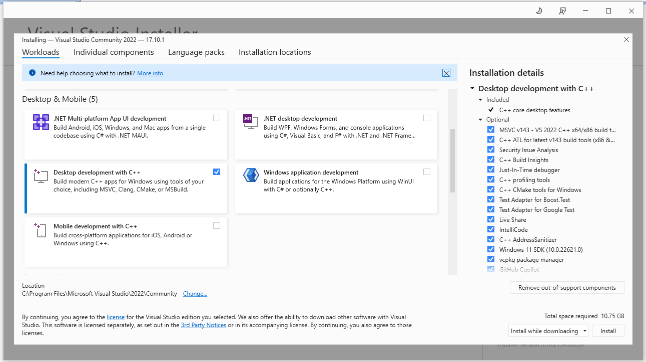

Important:

While Adding The Development Kit Ensure To Checkout The options marked in the Red box.

Step(2): Configuring the environment variables.

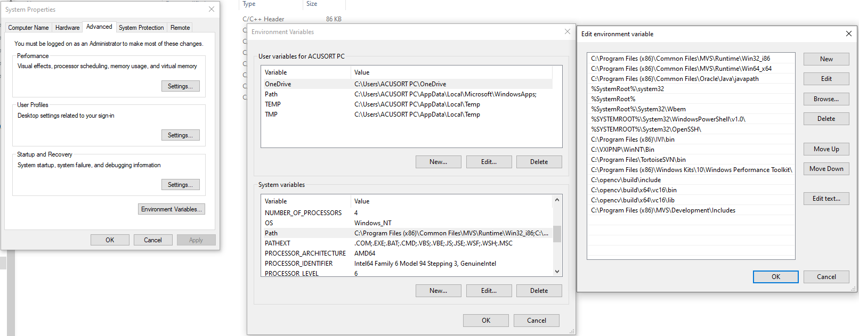

Step (3): Open An Empty Project In Visual Studio:

1. Click on the Visual Studio Community 2022 Icon.
2. Click on “Create a new project”.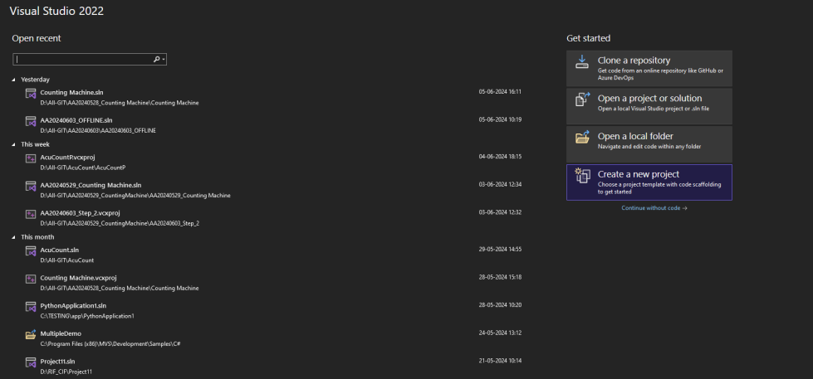
3. Click on “Empty Project”.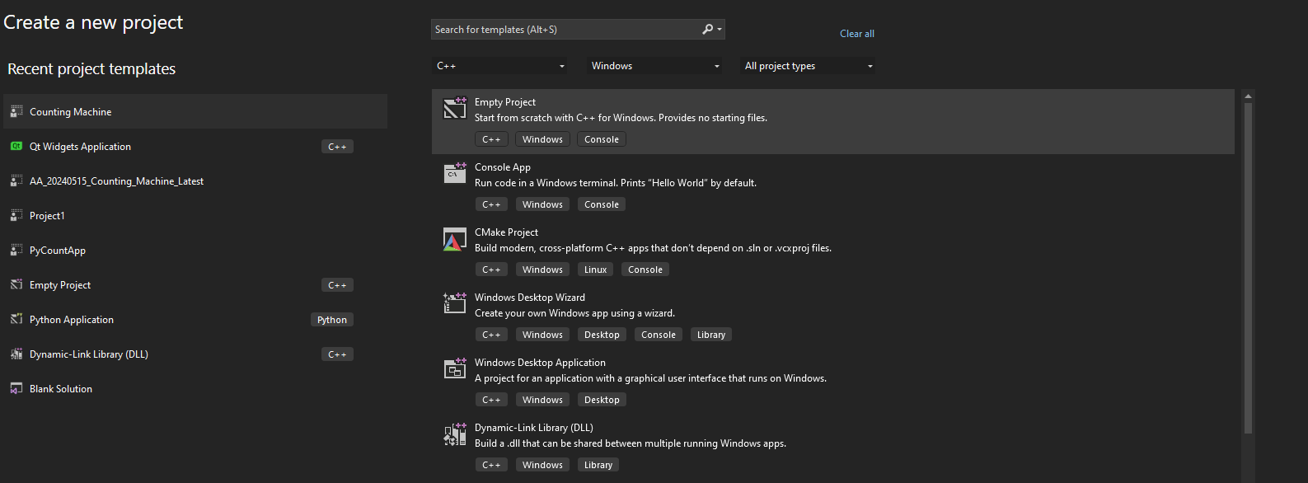
4. Click on “Next”.

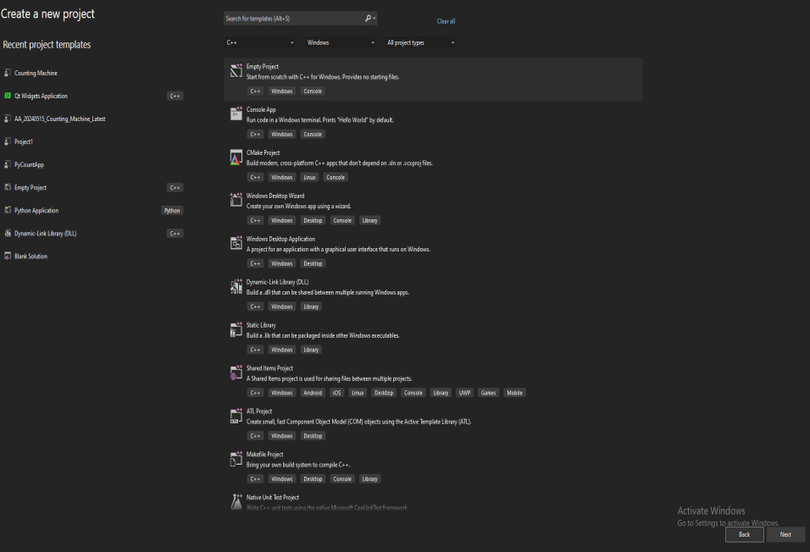

1. Enter the Project Name and select the location where you want to save it and click on create.

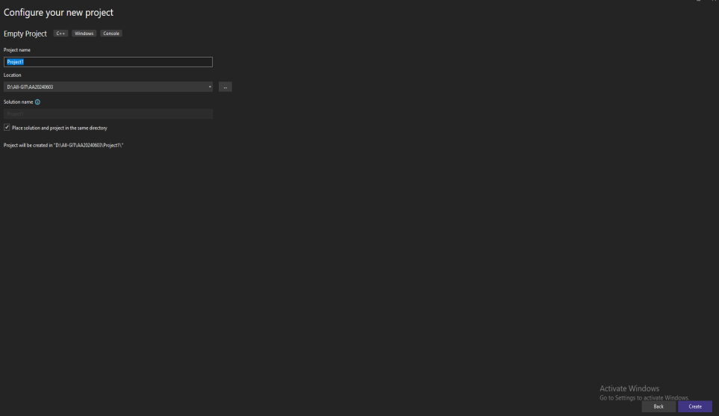

**Setting Up Properties For MVS In Visual Studio:**

Click On “Source Files” Located In The Right Side Menu Bar, Then Right Click And Press On “Add” Option,

Add A Cpp File And Click Ok.

Write The Code .

Then Right Click On The Code , Navigate To The Properties Options:

Then In C++ Settings , Add The Path To The Include Folder Of MVS.

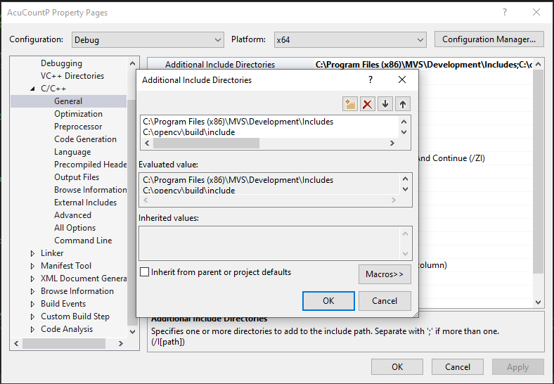

Then Right Click On “Project” In The Top Toolbar,Then Navigate To The Properties:

Debug Mode:

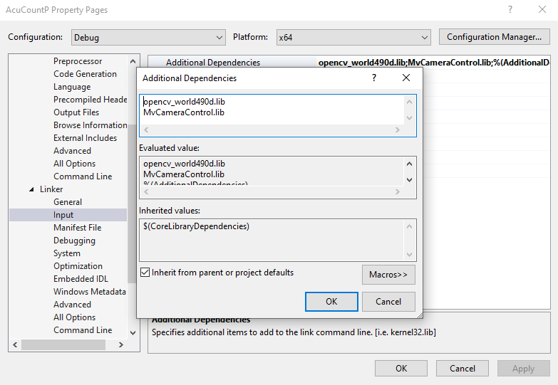

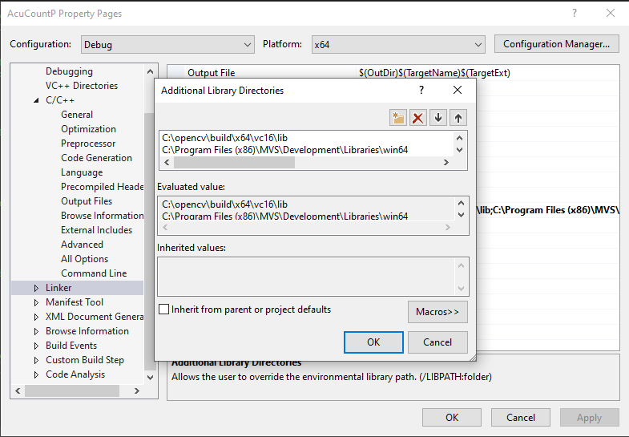

VERY IMPORTANT:

**ONCE ALL THE ABOVE IS COMPLETE THEN SAVE THE PROGRAM AND RESTART THE VISUAL STUDIO.**

**THEN RUN AGAIN THE APPLICATION.**

**You should get the following output from the given files below:**

**Output For MVS:**

**AA20240523_GOD.cpp**

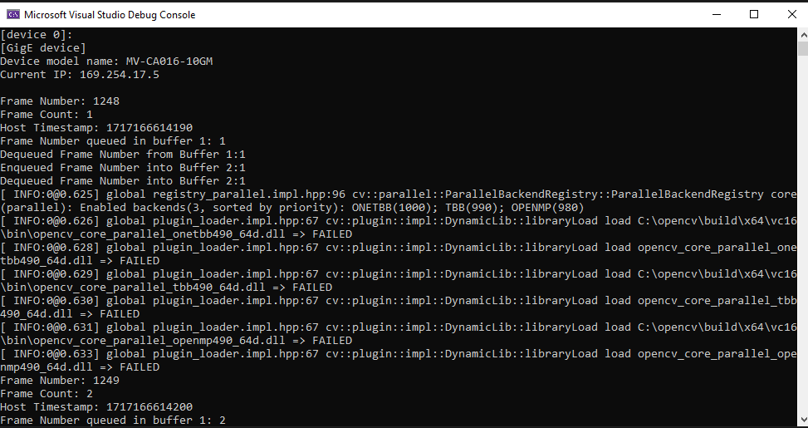

**Creating a Template of the project:**

**Why to create a Project Template:**

1. No need to setup the VS environment again from scratch.

2. If external libraries are included in your current VS setup then you just have to create a template of the project so that you can use it again and again without worrying about library addition.

**Steps to create a Template in Visual Studio VS:**

After the above steps of setting up the VS and OPENCV is complete and once the code is functional with the proper output at the end, then follow the steps below:

1. Click on “Project” and navigate to “Export Template”, click on it .

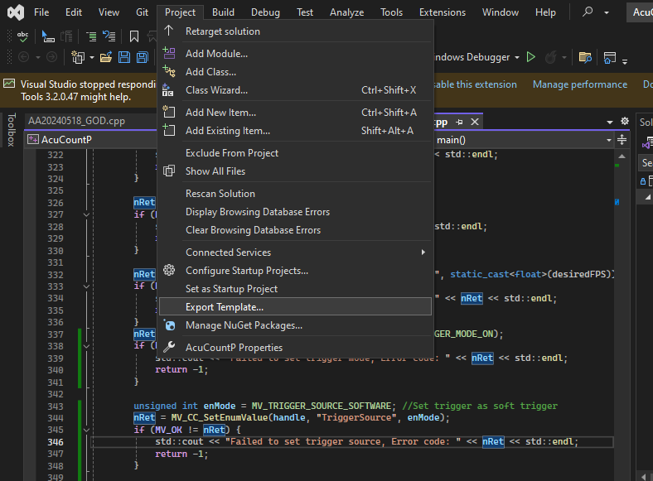

1. A new window will appear. Then select the “Project Template”, select “From which project would you like to create a template?” and then click on “Next>”

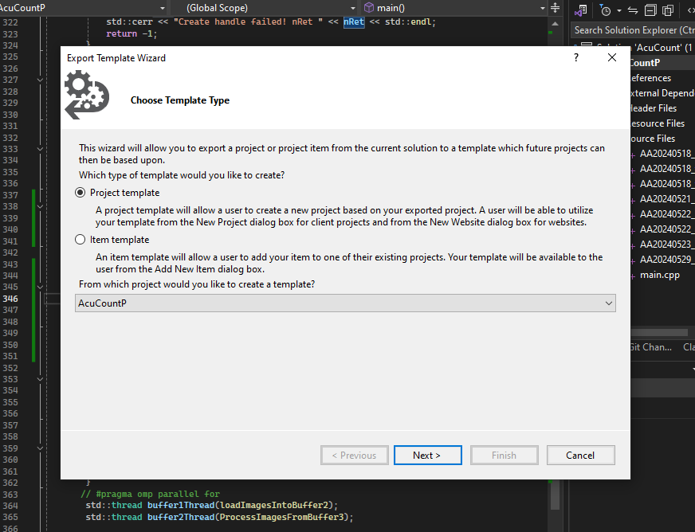

1. Write the “Template Name” and specify the “Output Location”.

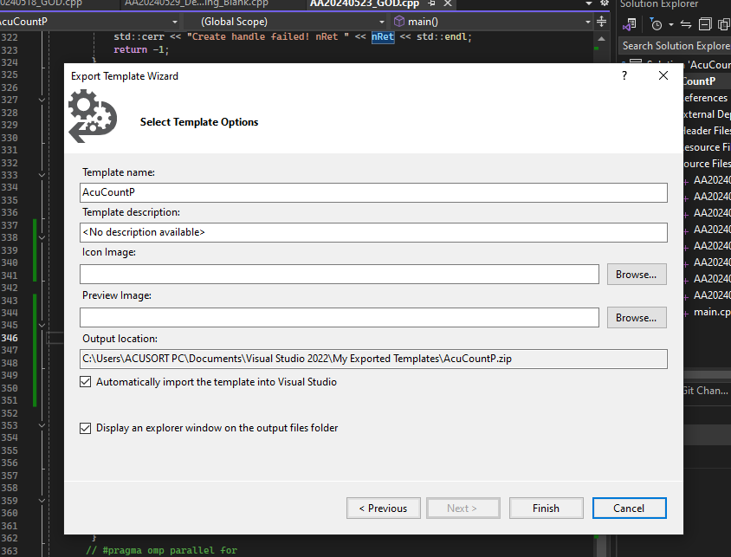

1. Have a note of the Template Name for later purpose of using the template.

**How to use a template:**

1. Launch VS and click on “Create a new project”.



1. Then in the Search Bar , enter in the Template Name you created prior and select the template name and once located ,press “Next”.

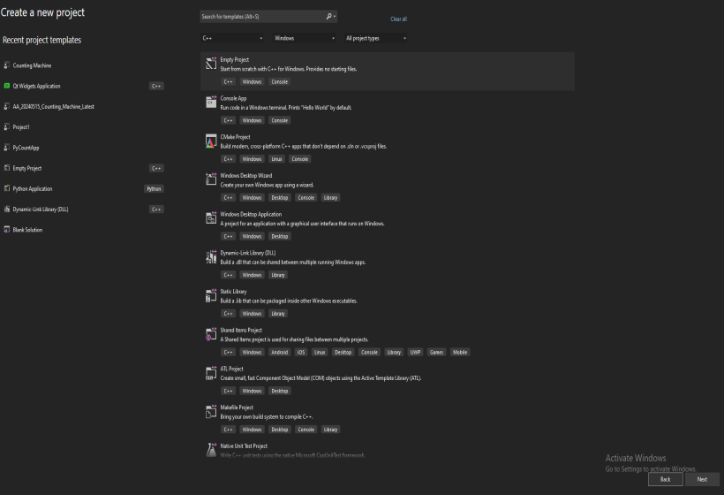

1. Enter the new Configurations and click “Create”.

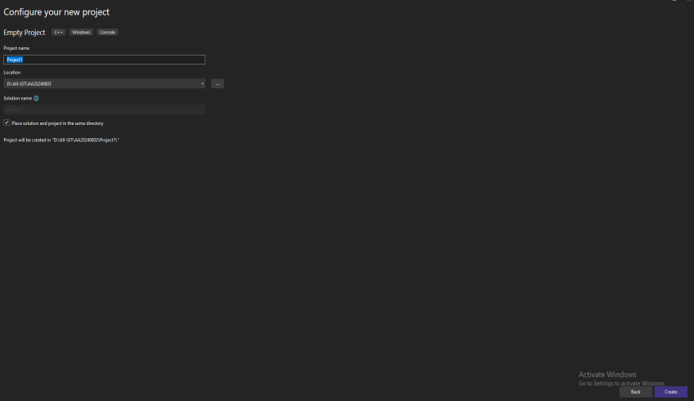

After this step, you setup for VS Template is ready to be utilized.